Chief Finance Officer

Office of the Police and Crime Commissioner Gloucestershire

Information for Applicants

Contents

Welcome letter from the Police and Crime Commissioner 3
Advertisement 5
Terms and Conditions of Appointment 6
Selection process 7
Job description 8
About the Police and Crime Commissioner 13

Welcome letter from the Police and Crime Commissioner

Dear Candidate,

Thank you for your interest in the post of Chief Finance Officer (CFO) to the Police and Crime Commissioner (PCC) for Gloucestershire. I hope that you will find the application pack a useful introduction to the role and to the Commissioner’s office.

Since its introduction in 2012, the role of Police and Crime Commissioner has grown in influence and service delivery. As a key community leader with significant statutory responsibilities in policing, crime reduction and community safety, I am committed to making Gloucestershire a safer place to live, work and visit. My office works very closely with the Gloucestershire Constabulary and other partners such as the County Council, District Councils, National Probation Service, Health, the voluntary sector and other public bodies to deliver my Police and Crime Prevention Plan.

The CFO is a key member of my Management Team, helping me to develop and implement strategy and to resource and deliver strategic objectives sustainably and in the public interest. They must be actively involved in, and able to bring influence to bear on, all material business decisions to ensure immediate and longer term implications, opportunities and risks are fully considered, and aligned with the financial strategy. The CFO will lead on the promotion and delivery of good financial management so that public money is safeguarded at all times and used appropriately, economically, efficiently and effectively.

The CFO is a statutory appointment made under the Police and Social responsibility act (2011) and will be the Gloucestershire Police and Crime Commissioners S.151 officer, ensuring arrangements are in place for proper financial administration and good governance. As such, the successful candidate will be a member of a specified accountancy body. The CFO will work closely with the Chief Executive in formulating and implementing a sound, sustainable business and financial strategy to support the delivery of the Police and Crime Prevention Plan, and advise on the financial implications of policy options and allocation of resources.

I hope that you find all the information which you require in this application pack, however should you have any queries on the role, please contact my Chief Executive, Richard Bradley at Richard.Bradley@Gloucestershire-PCC.Gov.uk

If you are up to the challenge, I look forward to hearing from you.

Yours Sincerely

Chris Nelson
Police and Crime Commissioner for Gloucestershire

Advertisement

Role: Chief Finance Officer – OPCC

Location: No.1 Waterwells, Waterwells Drive, Quedgeley, Gloucester GL2 2AN

Salary: £32,000 per annum ( £80,000 FTE)

Position Type: Part time – 16 hours per week

This is an exciting opportunity to support the delivery of the Gloucestershire Police and Crime Commissioner’s ambitious programme detailed in his Police and Crime Prevention Plan.

The Chief Finance Officer (CFO) will ensure proper financial administration and good governance. The CFO will work closely with the PCC and Chief Executive to formulate and implement a sound, sustainable business and financial strategy and advise on the financial implications of policy options and allocation of resources.
How to Apply

Selection for the role will be on merit on the basis of open competition. Application should be made by submitting a CV and covering letter clearly marked ‘PCC Chief Finance Officer’ to Richard Bradley, Chief Executive , Office of the Police and Crime Commissioner, Police HQ, No.1 Waterwells , Waterwells Drive, Quedgeley, Gloucester GL2 2AN.

This should be accompanied by Completed applications, together with an equality monitoring form (should you wish to complete one).

Closing date for applications: 12.00 noon, Thursday 2 June 2022

Interview date: Monday 13 June 2022

As this is a statutory appointment, the successful candidate is required to attend a Police and Crime Panel confirmation hearing on: Friday 9 September 2022.

Equal Opportunities

The Police and Crime Commissioner is firmly committed to promoting equality of opportunity for all local people and communities and is determined to ensure that:
- The workforce reflects the diverse society which it serves and that the working environment is free from any form of harassment, intimidation, bullying or victimisation
- No job applicant or employee is treated more or less favourably on the grounds of sex, gender reassignment, sexual orientation, age, marital status, pregnancy and maternity, race, colour, nationality, ethnic or national origins, religion or belief or disability. This is subject to the police service engaging in a positive action scheme in order to overcome or minimise any disadvantage connected to any of the protected characteristic listed above;
- No job applicant or volunteer is disadvantaged by a provision, criterion or practice which cannot be shown to be a proportionate means of achieving a legitimate aim.

Terms and Conditions of Appointment

Working location
The Police and Crime Commissioner’s Office is based in Police HQ, Waterwells, Quedgeley, Gloucester; however, the nature of the work involves travel throughout the county and beyond. Reimbursement of travel expenses for official duties will be made in accordance with the authorised allowance policy. Working from home is also permitted.

Working hours
The post is a part time appointment of 16 hours per week, some out of office hours working will be required e.g. for attendance at public meetings. The individual will be expected to have flexibility over when the hours are worked in order to represent the PCC at Governance meetings.

Working arrangements
All candidates should note that this is a politically restricted post subject to police vetting. As a statutory senior appointment to the office, the successful candidate will be required to attend a public confirmation hearing to enable the Police and Crime Panel to review the proposed appointment.

Selection process

Selection for the role will be on merit on the basis of open competition.

Candidates should submit a covering letter evidencing their ability to undertake the key responsibilities of the role and how their skills, experience and qualities fit with the requirements of the person specification. A CV should also be provided which includes details of employment history. Applicants must declare any potential conflict of interest as a result of their current or previous employment or personal circumstances and must disclose any outstanding criminal convictions, investigations or disciplinary proceedings relating to their conduct, unless expunged.

No applications will be accepted after 12 noon on Thursday 2 June 2022.

Shortlisting will be against the role outline and person specification, with candidates who pass the shortlisting process being invited for interview by a panel which will include the Police and Crime Commissioner. The interview will test the evidence presented in the application and the successful candidate will be determined by an objective marking scheme. Further details on the interview process will be provided to candidates who are successful at the shortlisting stage. Interviews are scheduled for Monday 13 June 2022.

Following the interview process, the Police and Crime Panel will be informed of the details of the Commissioner’s intended appointment so that a confirmation hearing can be arranged. The Commissioner will consider the recommendations of the Panel in relation to the appointment.

Job description

Job Title: Chief Finance Officer

Reports to: Chief Executive Officer

Salary: £32,000 per annum (£80,000 FTE) part time @16 hours per week – with flexibility for some home working)
Based at: Police HQ, No.1 Waterwells, Waterwells Drive, Quedgeley, Gloucester GL2 2 AN

Role summary

The key purpose of the role is to ensure the financial affairs of the Police and Crime Commissioner for Gloucestershire are properly administered and that sound financial management arrangements are in place across the Office of the Police and Crime Commissioner (OPCC) and Gloucestershire Constabulary. The PCC Chief Finance Officer (PCCCFO) also acts as strategic financial advisor to the Police and Crime Commissioner (PCC) and supports the Chief Executive in delivery of the PCC’s vision, strategy and identified priorities, advising on the financial implications of policy options and allocation of resources.

This is a statutory role and the statutory responsibilities are set out in the following legislation:

- Paragraph 6 of Schedule 1 to the Police Reform and Social Responsibility Act 2011
- Section 114 of the Local Government Finance Act 1988

This role is the Local Government Finance Act 1988 Section 151 Officer for the Police and Crime Commissioner for Gloucestershire.

Key working relationships

- The Police and Crime Commissioner and Chief Executive
- The Police and Crime Panel
- Joint Audit Committee
- Chief Constable’s CFO (CCCFO)
- Gloucestershire Constabulary Chief Constable and Chief Officers
- National and regional finance officer bodies and networks
- Local partnership finance leads

Key strategic and management responsibilities

The Chief Finance Officer is the Police and Crime Commissioner’s professional adviser on financial matters and will:

- be a key member of the OPCC Commissioners Management Team, working closely with the Chief Executive to implement strategy and to resource and deliver the PCC’s strategic objective sustainably and in the public interest

- advise the PCC, separately and in liaison with the Chief Constable and Chief Constable’s Chief Finance Officer (CCCFO), on the overall financial plan, particularly on the precept and grant, to ensure effective financial governance arrangements are in place, in line with best practice, and effectively communicated

- lead on development of the PCC’s financial strategy and be actively involved in, and able to bring influence to bear on all strategic business decisions of the OPCC, ensuring all financial implications, opportunities and risks are fully considered, and align with the OPCC’s financial strategy

- lead the promotion and delivery by the OPCC of good financial management so public money is safeguarded at all times and used appropriately, economically, efficiently and effectively; and must ensure the force finance function is resourced to be fit for purpose

- liaise with the Gloucestershire Constabulary Chief Finance Officer to advise the PCC and Chief Constable on value for money in relation to all aspects of OPCC and Chief Constable/Constabulary expenditure

- represent the OPCC at national and regional networks including the Police and Crime Commissioners Treasurers Society (PaCCTS)

- ensure publication of the Annual Statement of Accounts and other external reporting requirements of the Police and Crime Commissioner for Gloucestershire, in accordance with statutory requirements and deadlines

- lead on the development of the medium term financial strategy, and associated reserves and treasury management strategy and arrangements

- arrange for the determination and issuing of the relevant precept demands

- be jointly responsible with the Gloucestershire Constabulary CCCFO for managing the Internal Audit function

- take the lead role in supporting the effective functions of the Joint Audit Committee

- work closely with other OPCC staff to lead, develop and support the team

Statutory responsibilities

The Chief Finance Officer of the OPCC is responsible for:

- ensuring the financial affairs of the OPCC are properly administered and financial regulations are observed and kept up to date

- ensuring regularity, propriety and Value for Money (VfM) in the use of public funds

- ensuring the funding required to finance agreed programmes is available from government funding, precept, other contributions and recharges

- reporting to the PCC, the Police and Crime Panel and to the external auditor any unlawful, or potentially unlawful, expenditure by the PCC or officers of the OPCC

- reporting to the PCC, the Police and Crime Panel and to the external auditor when it appears expenditure is likely to exceed the resources available to meet that expenditure

- advising the PCC on the robustness of the budget and adequacy of financial reserves

- ensuring production of the statements of accounts of the OPCC

- ensuring receipt and scrutiny of the statement of accounts of the Chief Constable and ensuring production of the group accounts

- Treasury Management and control of what Bank Accounts Gloucestershire Constabulary can open and close

- advising the PCC in his statutory duty to manage the level of reserves that should be prudently maintained

- liaising with the internal auditor and the external auditor

- advising the PCC on the application of value for money principles by the police force to support the PCC in holding the Chief Constable to account for efficient and effective financial management

- advising, in consultation with the Chief Executive, on the safeguarding of assets, including risk management and insurance

Note: The CFO of the Police and Crime Commissioner for Gloucestershire has certain statutory duties which cannot be delegated, namely, reporting any potentially unlawful decisions by the PCC on expenditure and preparing each year, in accordance with proper practices in relation to accounts, a statement of the PCC of Gloucestershire’s accounts, including the Constabulary accounts. The Chief Finance Officer of the Office of the Police and Crime Commissioner is the PCC’s professional advisor on financial matters.

Knowledge, Skills and Competencies

1. | Member of a chartered accounting body. The qualifications for the Chief Finance Officer are set out in section 113 of the Local Government Finance Act 1988
2. | Understanding and ideally experience of fulfilling the role of a section 151 officer and the relevant statutory duties
3. | Experience of managing large multi-million pound budgets in a public sector organisation
4. | Experience of operating at a strategic level within a political and high profile environment
5. | Ability to devise sound and effective financial strategies, and to be innovative in developing better ways to deliver value for money and improved services
6. | Ability to identify, assess and manage financial risk effectively
7. | Ability to provide clear, authoritative and impartial advice based on objective financial analysis and interpretation of complex situations
8. | Knowledge of the financial environment within which policing operates
9. | Ability to give clear professional advice to political leaders and senior colleagues including the ability to challenge where legal and professional standards are not being upheld
10. | Ability to make sound and timely decisions, weighing up the wider impact of costs, benefits and risks involved
11. | Ability to work with and influence senior finance and other operational colleagues to achieve agreed objectives
12. | Understanding the importance of scrutiny, audit, governance and risk management arrangements
13. | Ability to network and build effective stakeholder relationships at a local and national level
14. | Ability to lead and manage staff, providing direction and guidance and effectively leading colleagues through change, as a key member of the OPCC Commissioners Management Team

Other Job Requirements

- To carry out other duties of the role as reasonably required by the Police and Crime Commissioner for Gloucestershire
- The post holder is required to successfully pass Security Check Vetting
- There may be occasions when the PCC requires additional out of hours working, which is arranged flexibly to accommodate individual needs
- This is a politically restricted post under Section 1 of the Local Government and Housing Act 1989. In summary, the restrictions for the post-holder include:

  - Becoming (whether by election or otherwise) or remaining a member of a Local Authority, of the National Assembly for Wales, of the European Parliament or of the House of Commons, or Police and Crime Commissioner
  - Announcing, or allowing others to announce, ones candidature for one of the aforementioned officers;
  - Holding office in a political party;
  - Canvassing at elections; and
  - Speaking or writing publicly on matters of party political controversy

The post holder should note that some or all of the duties and responsibilities detailed in this Job Profile require compliance with nationally agreed operating rules for accessing information systems.

- Data Protection Act 1998
- Computer Misuse Act 1990
- Official Secrets Act 1989

About the Police and Crime Commissioner

My Police and Crime Prevention Plan for 2021/25 includes the following priorities:

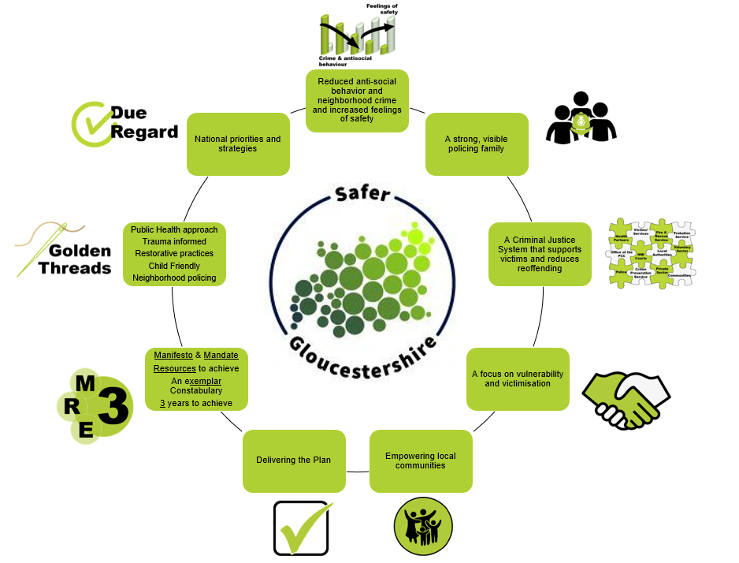

To support the delivery of my plan I have allocated £100,000 of the policing budget to create the ‘Commissioner’s Community Fund’. This Fund is made available on an annual basis to our local communities who are invited to make applications for projects or initiatives that would support the delivery of one or more of my priorities. Through the OPCC Commissioning Team we also manage a number of other funding streams including the annual Ministry of Justice Victims grant and other funds awarded through a bidding process for new Government funding e.g Safer Streets. We are responsible for the commissioning of services for victims of crime, sexual violence and domestic abuse.

My aim is that the plan will be delivered through the inclusion and involvement of the many partnerships, and communities we have in Gloucestershire with the aim of making it a safer place in which to live and work.

More details can be found using the following link: https://www.gloucestershire-pcc.gov.uk/

Chris Nelson
Police and Crime Commissioner for Gloucestershire

CONFIDENTIAL

Equal opportunities monitoring form

The information on this form is for monitoring purposes only and will not be made available to those assessing your application. The information supplied will be treated in the strictest confidence and will not affect your job application in any way.

Completion of this form is voluntary, but the information will help us ensure equality of opportunity. This information forms no part of the recruitment process.

GENDER  Male ☐  Female ☐  Prefer not to say ☐  AGE  18 – 24 ☐  25 – 35 ☐  36 – 60 ☐  Prefer not to say ☐  SEXUAL ORIENTATION  Bisexual ☐  Gay/Lesbian ☐  Heterosexual ☐  Prefer not to say ☐  RELIGION OR BELIEF  Buddhist ☐  Christian ☐  Hindu ☐  Jewish ☐  Muslim ☐  Sikh ☐  Other (please state) ☐  None ☐  Prefer not to say ☐  DISABILITY  Yes ☐  No ☐  Prefer not to say ☐ | ETHNIC GROUP  White  British ☐  Irish ☐  Any other white background ☐  Mixed  White & Asian ☐  White & Black Caribbean ☐  Any other mixed background ☐  Asian or Asian British  Bangladeshi ☐  Indian ☐  Pakistani ☐  Any other Asian background ☐  Black and Black British  African ☐  Caribbean ☐  Any other Black background ☐  Chinese or other ethnic group  Chinese ☐  Any other (please state) ☐  Prefer not to say ☐
* Under the Equality Act 2010 a person is defined as disabled if they have (or have recovered from) a physical or mental impairment and the impairment has a substantial and long term adverse effect on the person’s ability to carry out normal day-to-day activities. Cancer, HIV infection and multiple sclerosis are all conditions that are defined under the Equality Act 2010

